

University of Management and Technology

DATABASE MANAGEMENT SYSTEM (LAB)

Project ERD, Relational Schema and Normalization

Name: Urwa Manzoor (F2023266953)
Section: V12
Resource Person: Riaz Ahmad

ERD

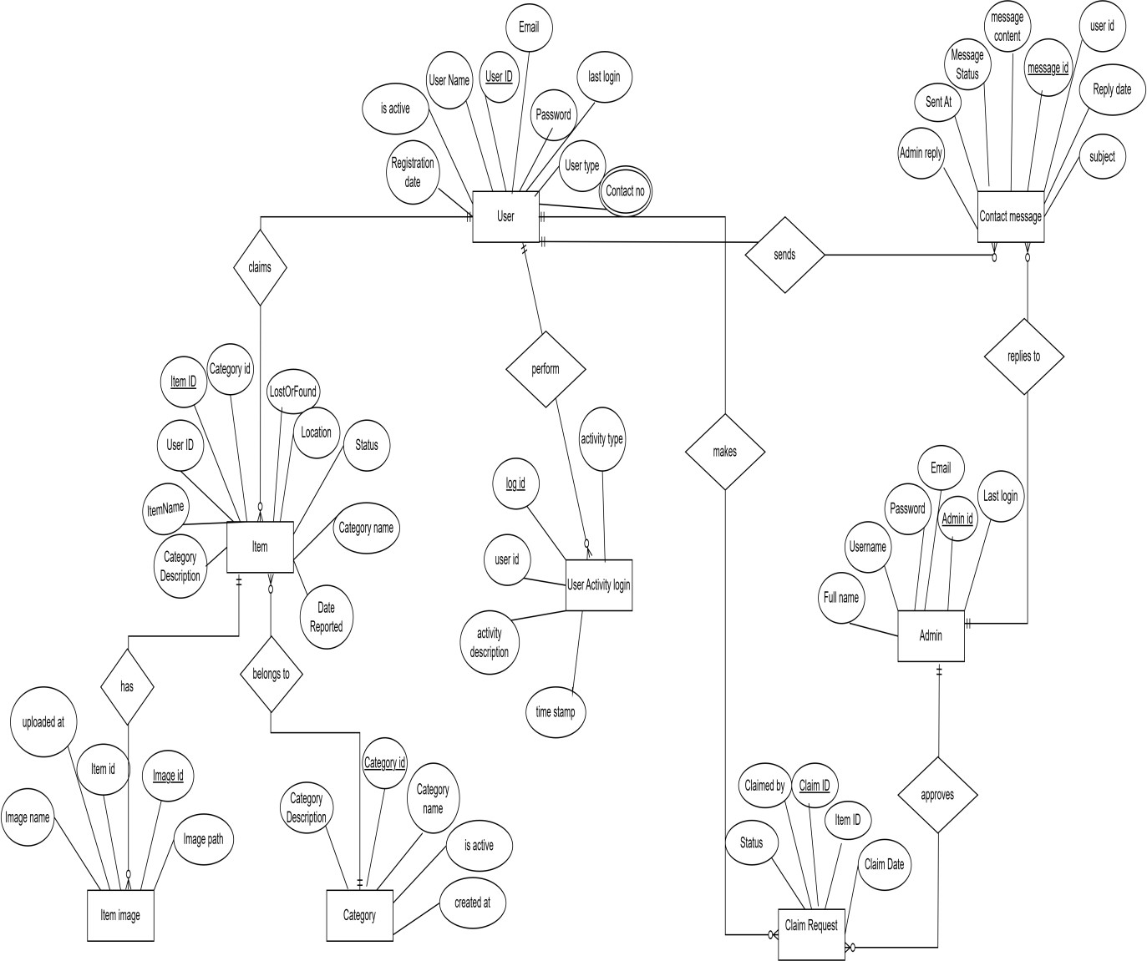

RELATIONAL SCHEMA

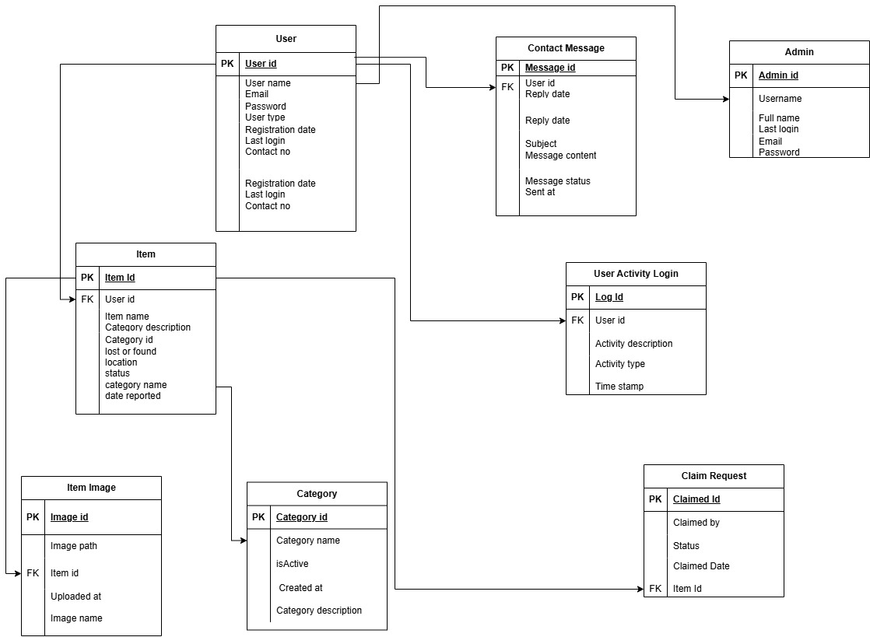

NORMALIZATION

User Table:
  - UNF to 1NF: Ensure all attributes are atomic (no repeating groups or arrays). All attributes are already atomic.
  - 1NF Result: No changes needed.
  - 1NF to 2NF: Ensure no partial dependency (all non-key attributes must depend on the entire primary key). Since User id is the only candidate key, and all attributes depend on it, there are no partial dependencies.

  - 2NF Result: No changes needed.

  - 1NF to 3NF: Ensure no transitive dependencies (non-key attributes must not depend on other non-key attributes). All attributes depend directly on User_id, so no transitive dependencies exist.

  - 3NF Result: The table is already in 3NF.

User id | Username | Email | Password | User  Type | Registration  date | Last  login | Contact no

Contact Message Table:
  - UNF to 1NF: All attributes are atomic.
    - 1NF Result: No changes needed.

  - 1NF to 2NF: Check for partial dependencies. Since Message_id is the PK and User_id is a FK, all non-key attributes (Reply_date, Subject, Message_content, Message_status, Sent_at) depend on Message_id. No partial dependencies.
    - 2NF Result: No changes needed.

  - 1NF to 3NF: Check for transitive dependencies. All non-key attributes depend on the PK (Message_id), and there are no dependencies between non-key attributes (e.g., Message_status does not determine Reply_date).
    - 3NF Result: The table is already in 3NF.

Message  id | User id | Reply  date | Subject | Message  content | Message  status | Sent at

3-Item Table:
- UNF to 1NF: The attribute Category description and Category name suggest a potential relationship with a separate Category table. Split these into a separate table.
  - 1NF Result: Move Category name and Category description to a Category table and retain Category id (FK) in Item.

- 1NF to 2NF: Ensure no partial dependencies. All attributes depend on Item_id, so no partial dependencies.
  - 2NF Result: No changes needed after 1NF adjustment.

- 1NF to 3NF: Check for transitive dependencies. Category description (if retained) would depend on Category name, which is transitive. Since we moved it to Category, no transitive dependencies remain.
  - 3NF Result: The table is in 3NF with the Category id FK.

Item id | User id | Category  Id | Item name | Lost or  found | location | status | Date  reported

Item Image Table:

  - UNF to 1NF: All attributes are atomic.
    - 1NF Result: No changes needed.

  - 1NF to 2NF: No partial dependencies since all attributes depend on Image_id.
    - 2NF Result: No changes needed.

  - 1NF to 3NF: No transitive dependencies.
    - 3NF Result: The table is already in 3NF.

Image Id | Item Id | Image path | Uploaded at | Image name

Category Table:

  - UNF to 1NF: All attributes are atomic.
    - 1NF Result: No changes needed.

  - 1NF to 2NF: No partial dependencies since all attributes depend on Category_id.
    - 2NF Result: No changes needed.

  - 1NF to 3NF: No transitive dependencies.
    - 3NF Result: The table is already in 3NF.

Category id | Category name | isActive | Created at | Category  description

User Activity Log Table:

  - UNF to 1NF: All attributes are atomic.
    - 1NF Result: No changes needed.

  - 1NF to 2NF: No partial dependencies since all attributes depend on Log id.
    - 2NF Result: No changes needed.

  - 1NF to 3NF: No transitive dependencies.
    - 3NF Result: The table is already in 3NF.

Log id | User id | Activity  description | Activity type | Time stamp

Admin Table:

  - UNF to 1NF: All attributes are atomic.
    - 1NF Result: No changes needed.

  - 1NF to 2NF: No partial dependencies since all attributes depend on Admin_id.
    - 2NF Result: No changes needed.

  - 1NF to 3NF: Username (FK) might suggest a relationship with User, but since it's an Admin-specific table, no transitive dependencies exist within this table.
    - 3NF Result: The table is already in 3NF.

Admin id | Username | Full name | Last login | Email | Password

Claim Request Table:

  - UNF to 1NF: All attributes are atomic.
    - 1NF Result: No changes needed.
  - 1NF to 2NF: No partial dependencies since all attributes depend on Claimed_id.
    - 2NF Result: No changes needed.
  - 1NF to 3NF: No transitive dependencies.
    - 3NF Result: The table is already in 3NF.

Claim id | Claimed by | Status | Claim date | Item id

